Course Name | ITD 2343 – Object Oriented Programming with C#
Instructor | Mark L. Pranger
Student Name | Eric Christensen
Due date | Oct 26, 2025
Grade | <grade earned here>
Grading Comments | <instructor comments here>

Week 7 – Programming Lab

Screen Shots needed for Submission:
- Make a screen shot for each of the following points in the creation process
  - The form after you have completed all the visual changes specified in the UI design. Many of the changes will not show in a screen shot but the color change will
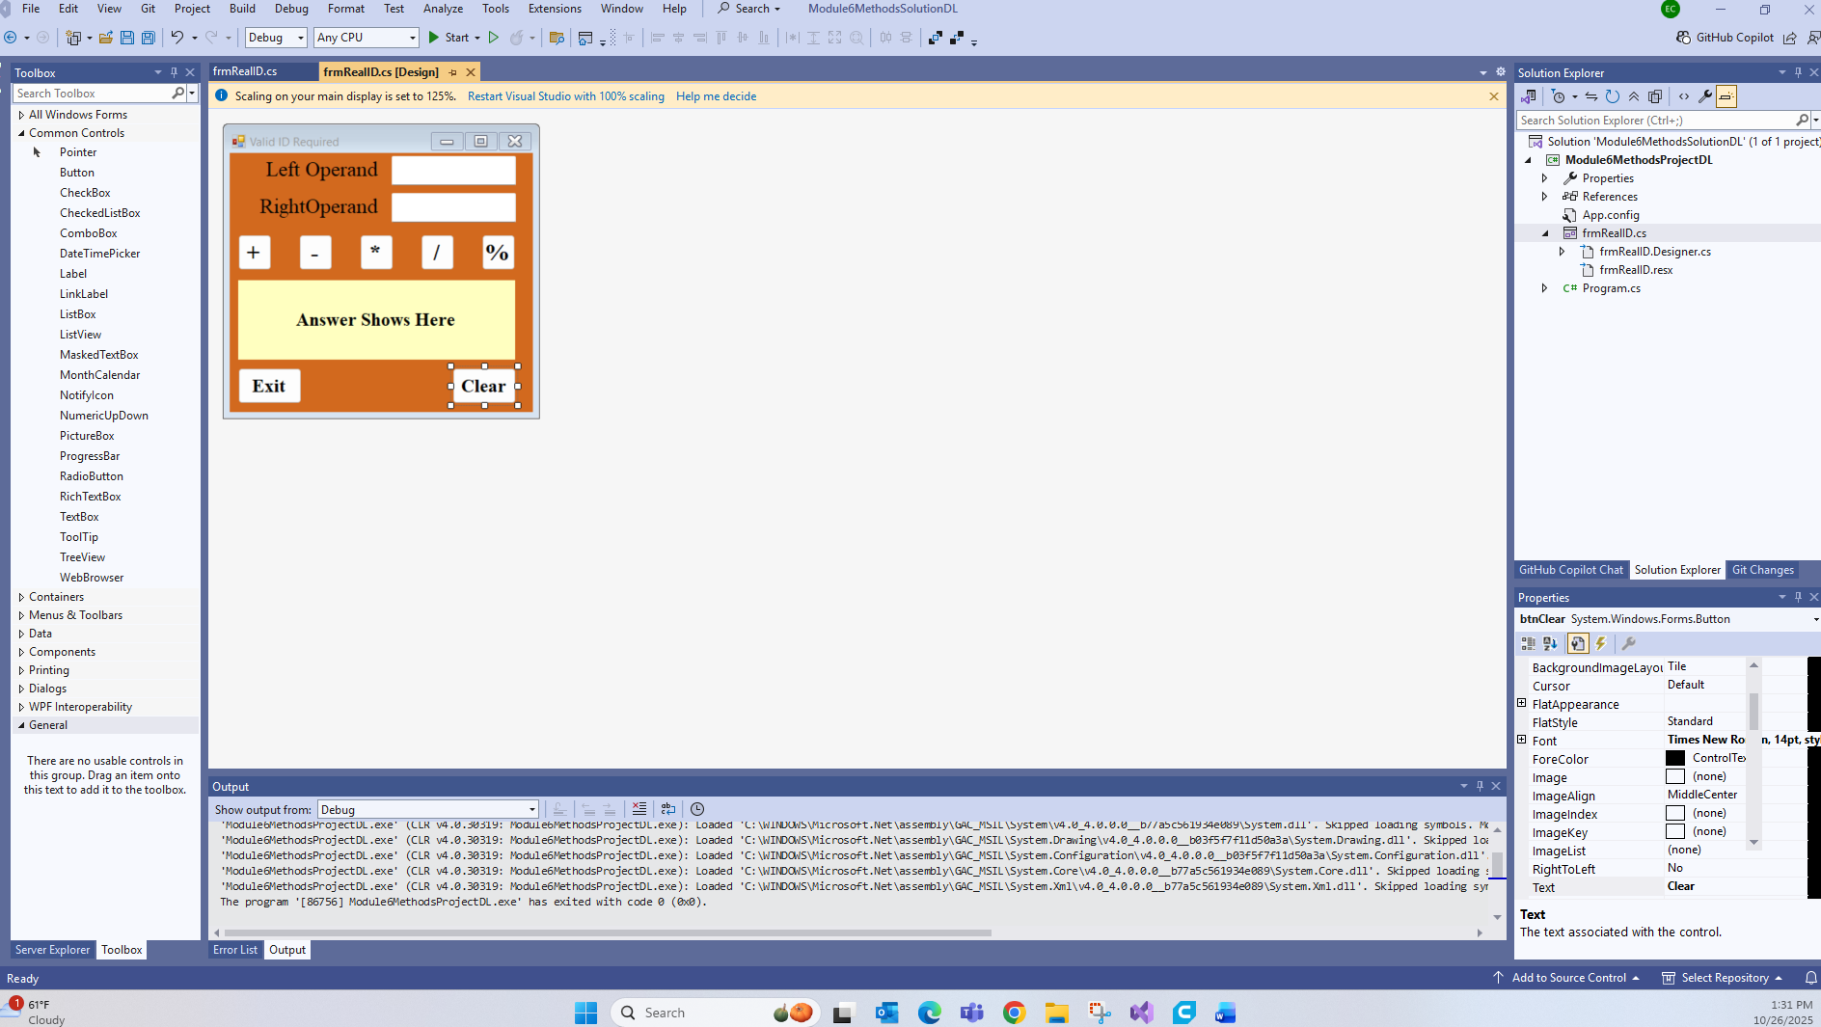
- Show the code for the validation and exception handling you create in as few screen shots as possible
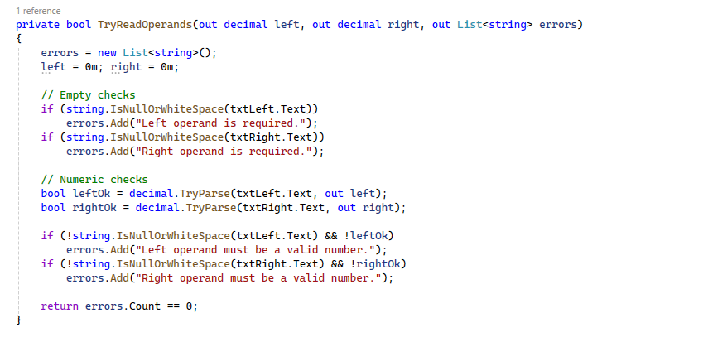
- Run the application in debug mode, screen shot the whole screen showing the form starting up
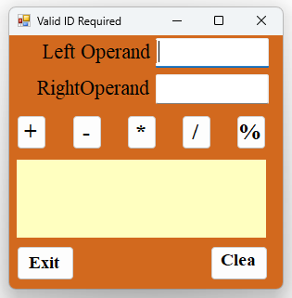

- For the operations screen shots, show one screen shot depicting each of the following scenarios

  - Error message for missing information in the textboxes
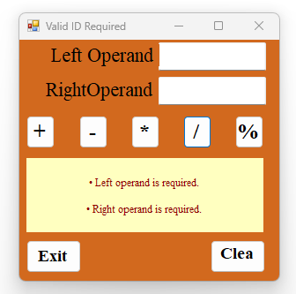

  - Error message for non numbers in the textboxes
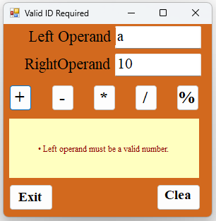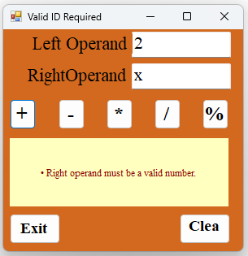

  - Divide by Zero message
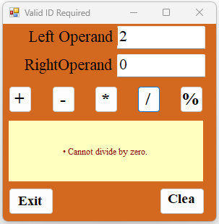

  - Negative Numbers on Modulus message
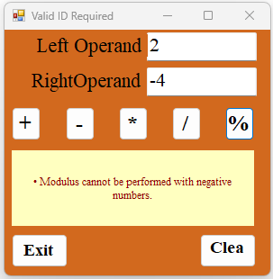

  - Show multiple errors happening together and the resulting messages all displayed together
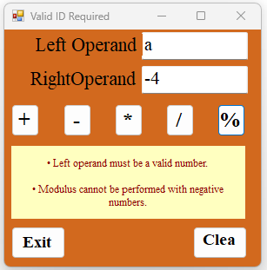

  - You will not be able most likely to produce an "unexpected" error but the code will need to be there to handle those unexpected errors
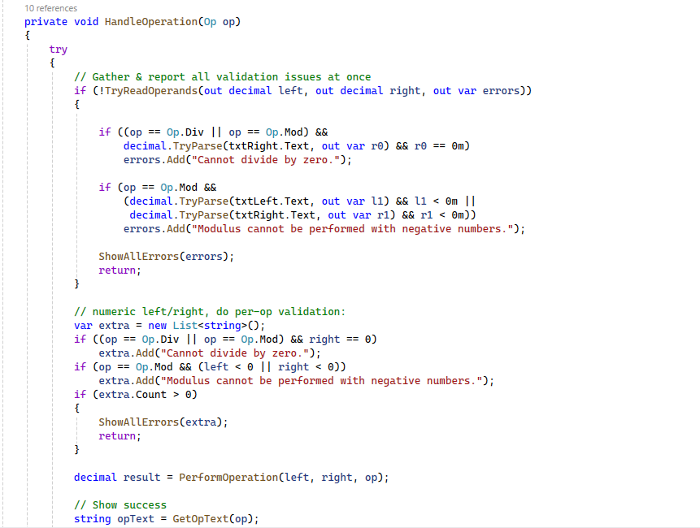
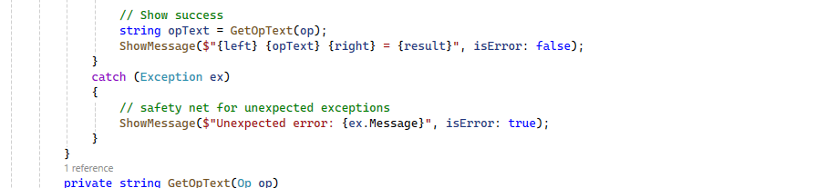

  - Show each error message that you can produce (multiple screenshots required)
